Retail Sales Analysis Project
A comprehensive data analysis of retail sales transactions using SQL. This project covers data cleaning, exploration, and business insights through 10 key analytical questions.
📊 Project Overview
- Dataset: Retail sales transactions
- Tools: SQL Server (SSMS)
- Analysis Focus: Sales trends, customer behavior, category performance, and time-based patterns
🧩 Key Questions & Insights
- Sales on 2022-11-05
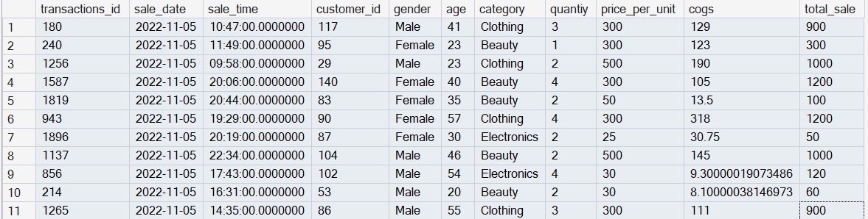

- High-quantity clothing sales in Nov 2022
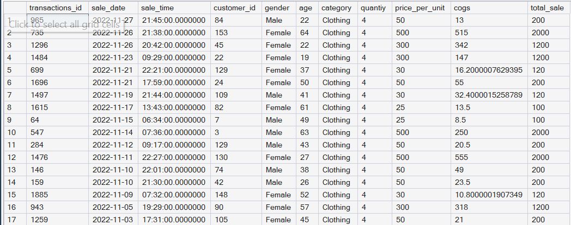

- Total sales by category
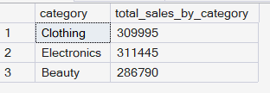

- Average age of Beauty customers
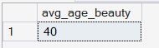

- High-value transactions (> $2000)
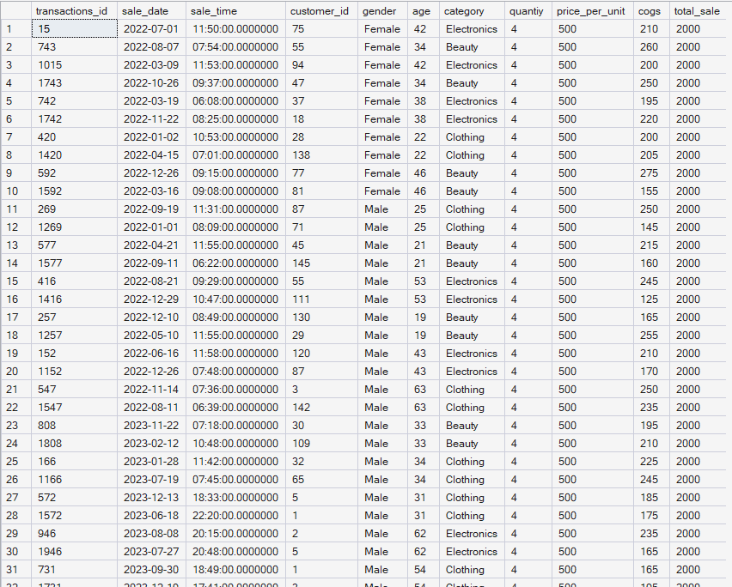
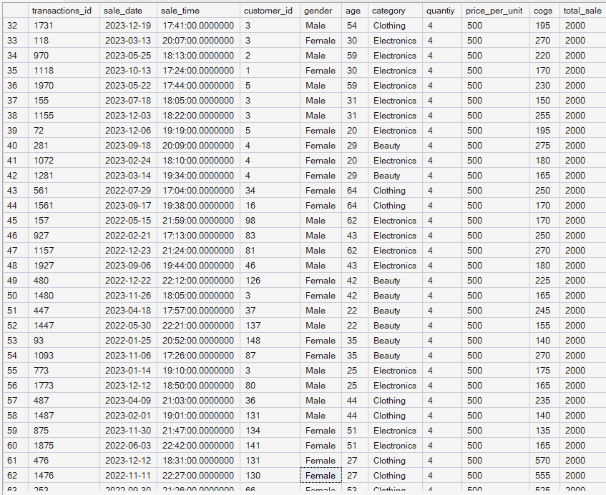
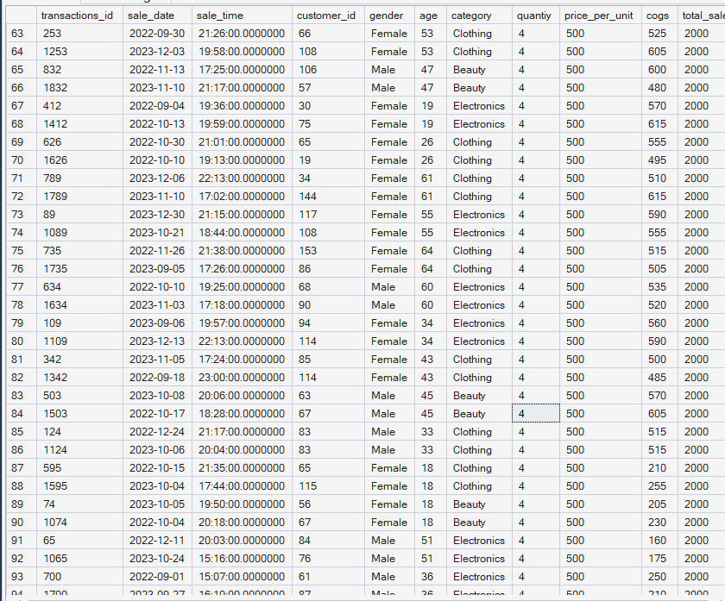
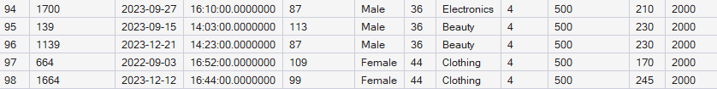
- Transactions by gender and category
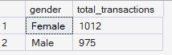
- Best-selling month per year
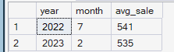

- Top 5 customers by total spending
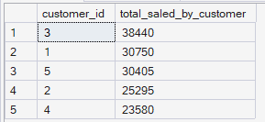
- Unique customers per category
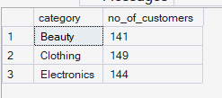
- Order volume by time of day (Morning/Afternoon/Evening)
